AWS Transit Gateway and VPC Endpoints for Multi-VPC Architecture
Objective: Design and implement a scalable, secure, and efficient AWS network architecture for a multi-VPC environment.
The solution was designed to:
- Enable communication between multiple VPCs using AWS Transit Gateway.
- Simplify network management by avoiding complex VPC peering connections.
- Provide secure access to AWS services using VPC Endpoints.
- Eliminate the need for public internet access when accessing AWS services.
- Improve security and reduce exposure to external threats.
- Demonstrate enterprise-level networking architecture suitable for large organizations.

Use Case
A large organization is migrating workloads from on-premises infrastructure to AWS Cloud.
The organization requires:
- Separate VPCs for different departments and workloads.
- Centralized connectivity between VPCs.
- Secure communication between resources.
- Private access to AWS services without traversing the internet.
- A scalable architecture that can support future expansion.
To meet these requirements, AWS Transit Gateway and VPC Endpoints were implemented.

Solution Architecture
VPC Design
VPC Name | CIDR Block | Purpose
Shared-Services-VPC | 10.0.0.0/16 | Bastion Host and Shared Services
Application-VPC | 10.1.0.0/16 | Application Servers
Database-VPC | 10.2.0.0/16 | Database Layer
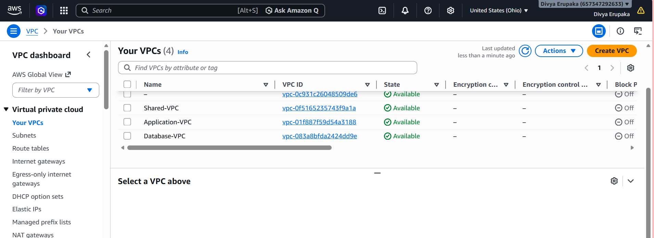
Subnet Design
VPC | Subnet | CIDR
Shared-Services-VPC | Shared-Subnet | 10.0.1.0/24
Application-VPC | App-Subnet | 10.1.1.0/24
Database-VPC | DB-Subnet | 10.2.1.0/24
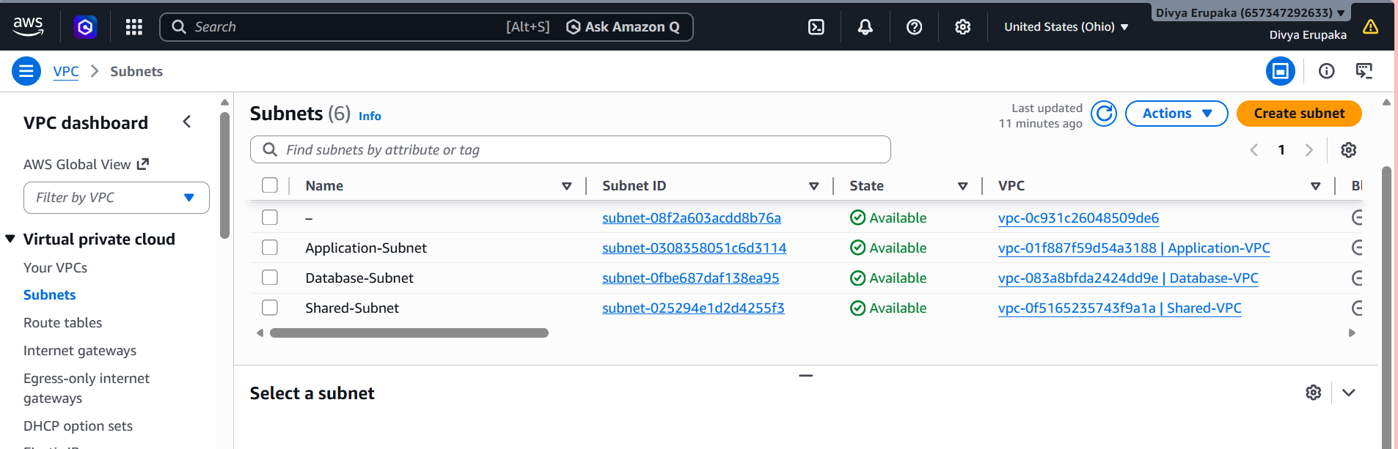
Architecture Diagram
AWS Transit Gateway
|
---------------------------------------------------
| | |
| | |
V V V
+----------------+ +----------------+ +----------------+
| Shared Services| | Application | | Database |
| VPC | | VPC | | VPC |
| 10.0.0.0/16 | | 10.1.0.0/16 | | 10.2.0.0/16 |
+----------------+ +----------------+ +----------------+
| | |
| | |
Shared-EC2 App-EC2 DB-EC2
|
|
S3 Gateway Endpoint
|
|
Amazon S3

Implementation Steps
Step 1 – Created Shared Services VPC
Created a VPC named:
Shared-Services-VPC
CIDR:
10.0.0.0/16
Purpose:
- Centralized management
- Bastion Host access

Step 2 – Created Application VPC
Created:
Application-VPC
CIDR:
10.1.0.0/16
Purpose:
- Application hosting

Step 3 – Created Database VPC
Created:
Database-VPC
CIDR:
10.2.0.0/16
Purpose:
- Database workloads

Step 4 – Created Subnets
Created one subnet in each VPC.
Shared Services Subnet
10.0.1.0/24
Application Subnet
10.1.1.0/24
Database Subnet
10.2.1.0/24

Step 5 – Created Security Groups
Configured Security Groups with:
Inbound Rules
Type | Port | Source
SSH | 22 | My IP
ICMP | All | 10.0.0.0/8
Outbound Rules
Type
All Traffic

Step 6 – Launched EC2 Instances
Three EC2 instances were launched.
Instance | VPC
Shared-EC2 | Shared-Services-VPC
App-EC2 | Application-VPC
DB-EC2 | Database-VPC
Amazon Linux 2023 AMI was used for all instances.
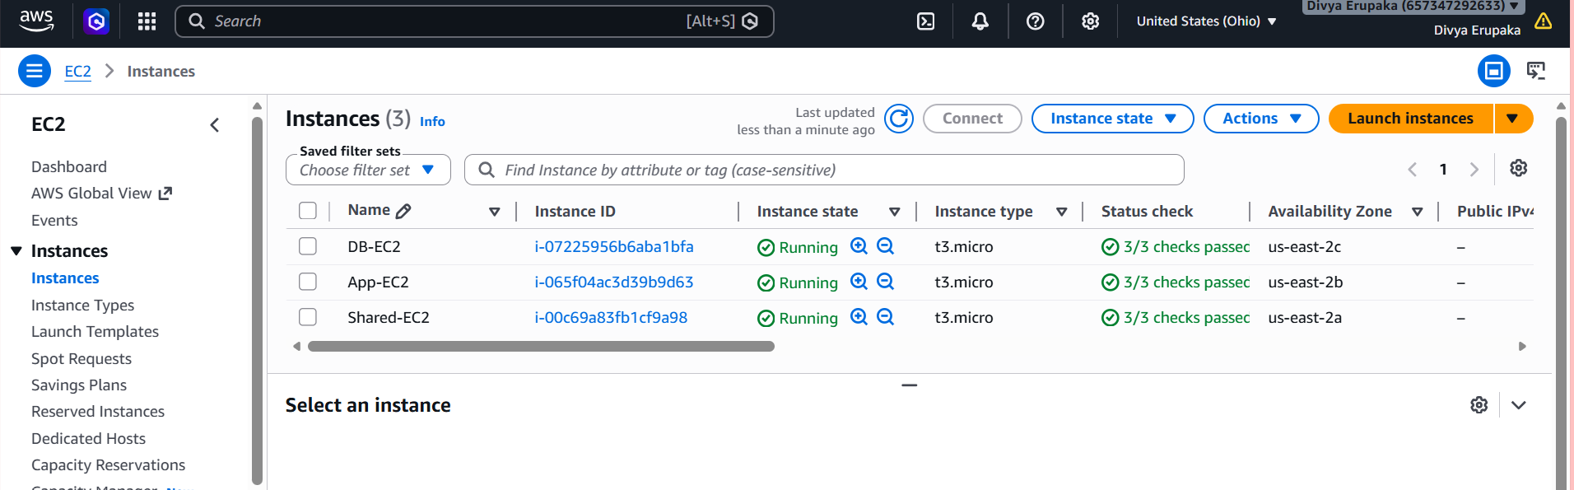
Step 7 – Created Internet Gateways
Created and attached Internet Gateways.
Internet Gateway | Attached VPC
Shared-IGW | Shared-Services-VPC
App-IGW | Application-VPC
DB-IGW | Database-VPC
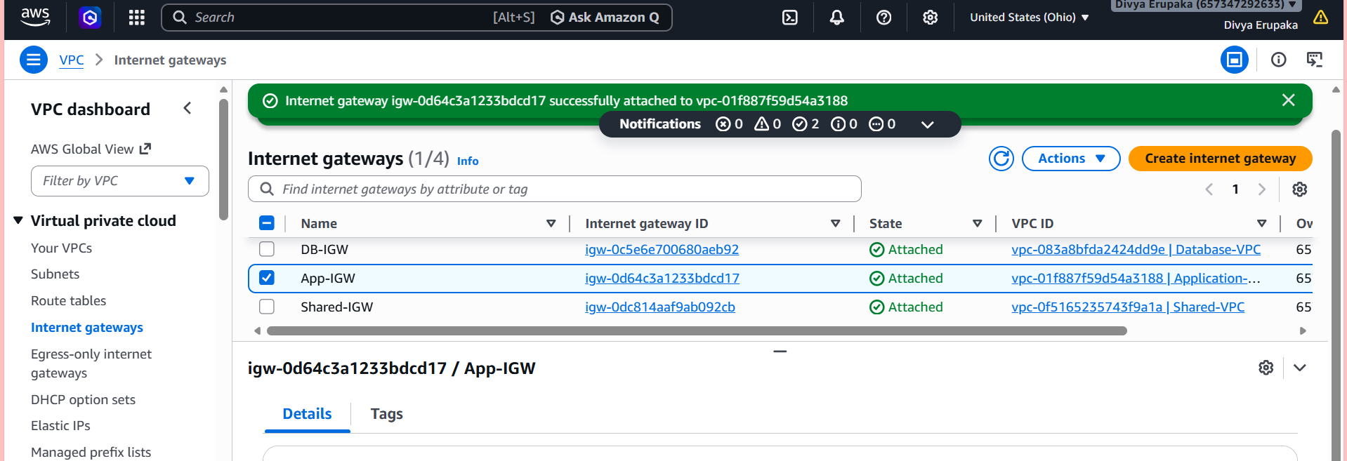
Step 8 – Updated Route Tables
Configured default route:
0.0.0.0/0 → Internet Gateway
for internet connectivity.
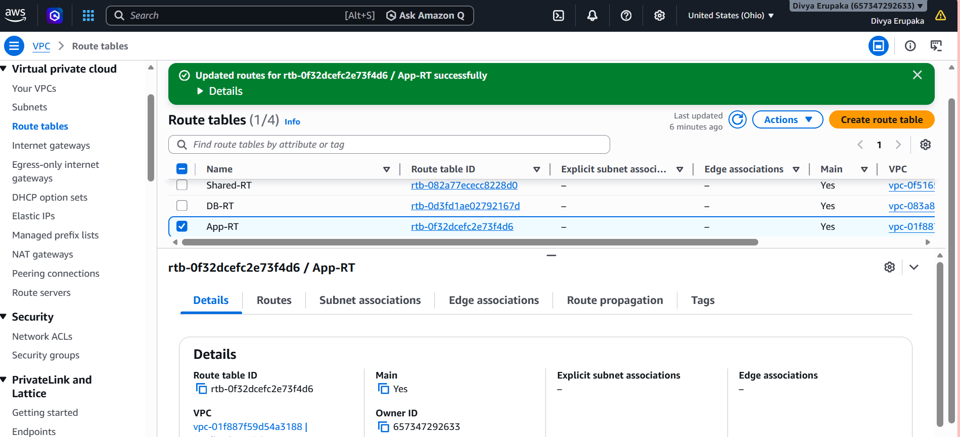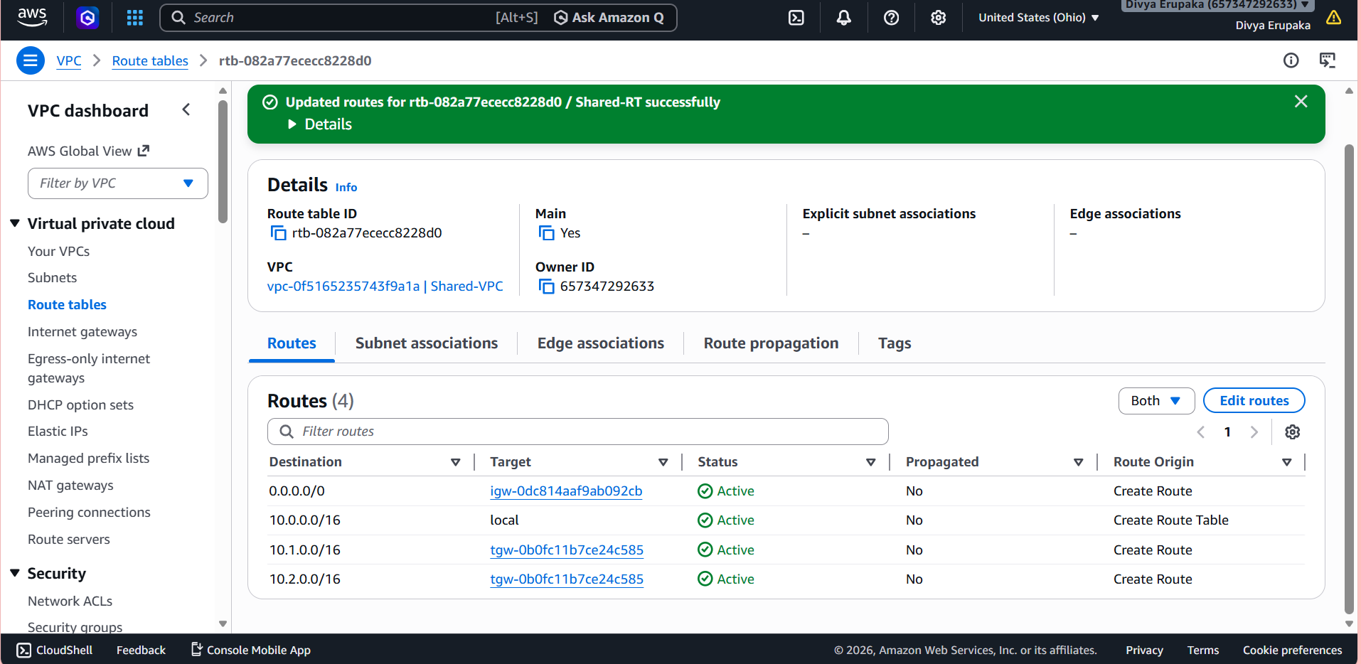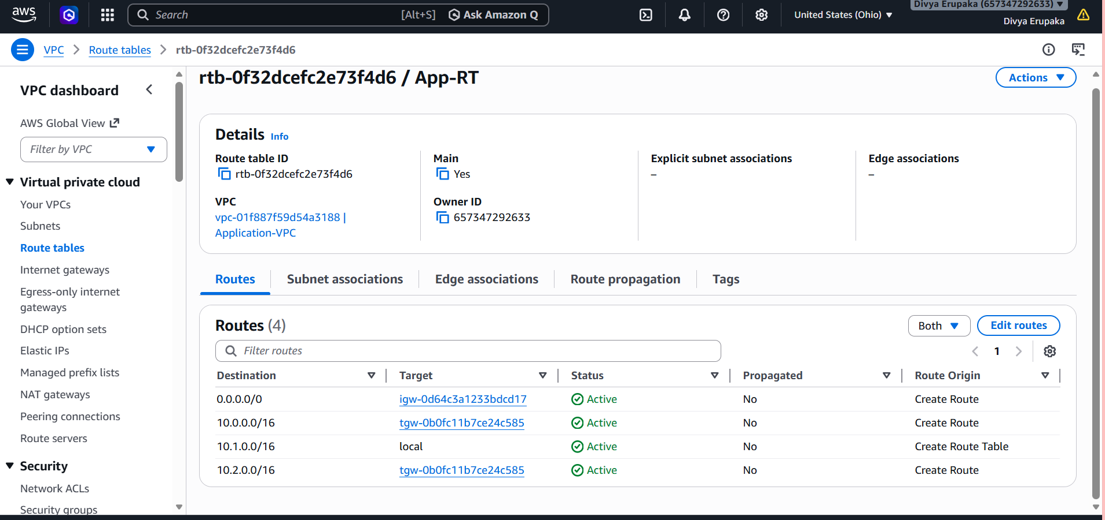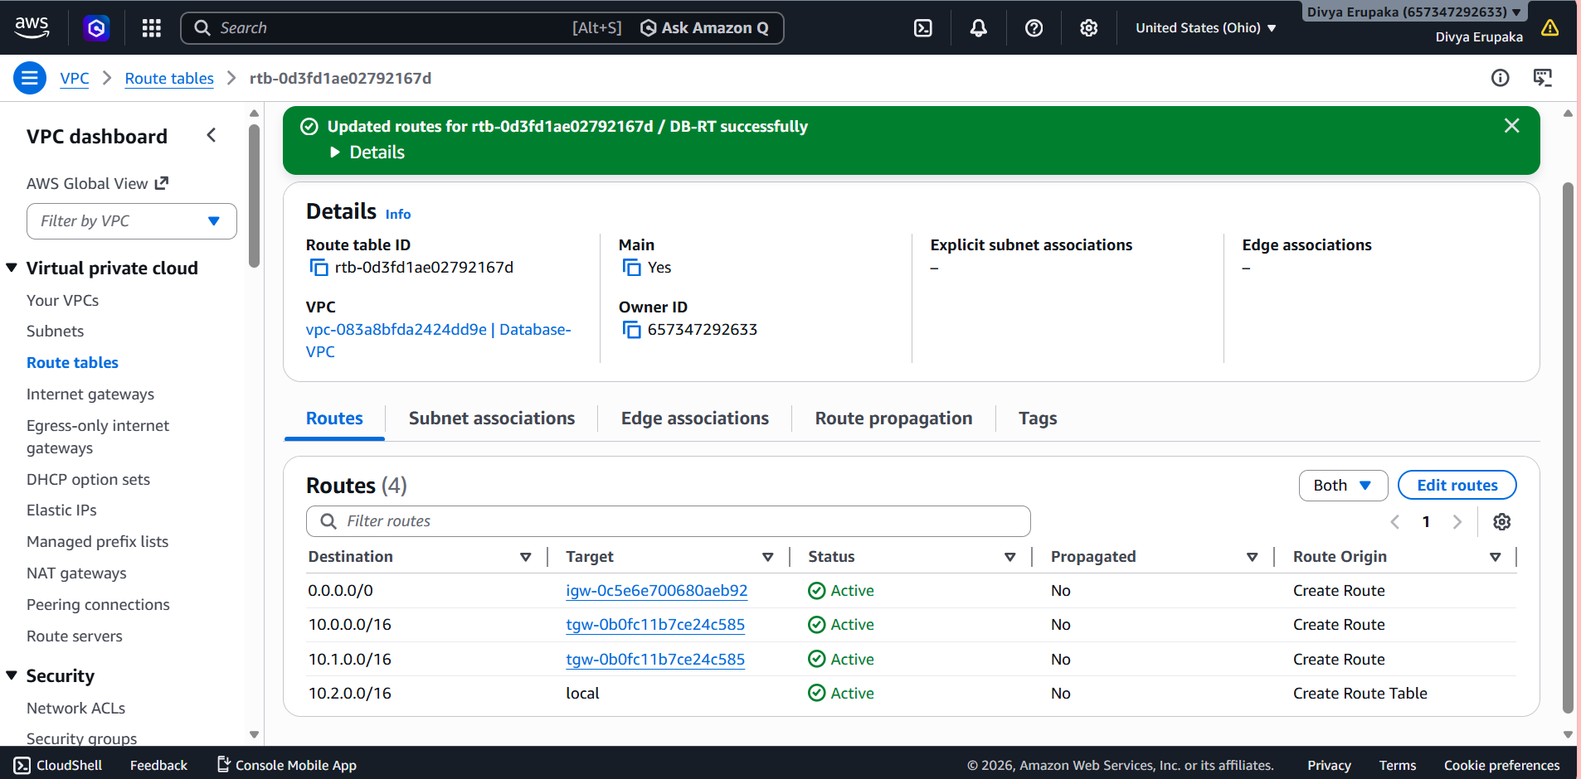
Step 9 – Created AWS Transit Gateway
Created Transit Gateway:
Organization-TGW
Amazon ASN:
64512
Purpose:
- Centralized connectivity between VPCs
- Simplified network architecture
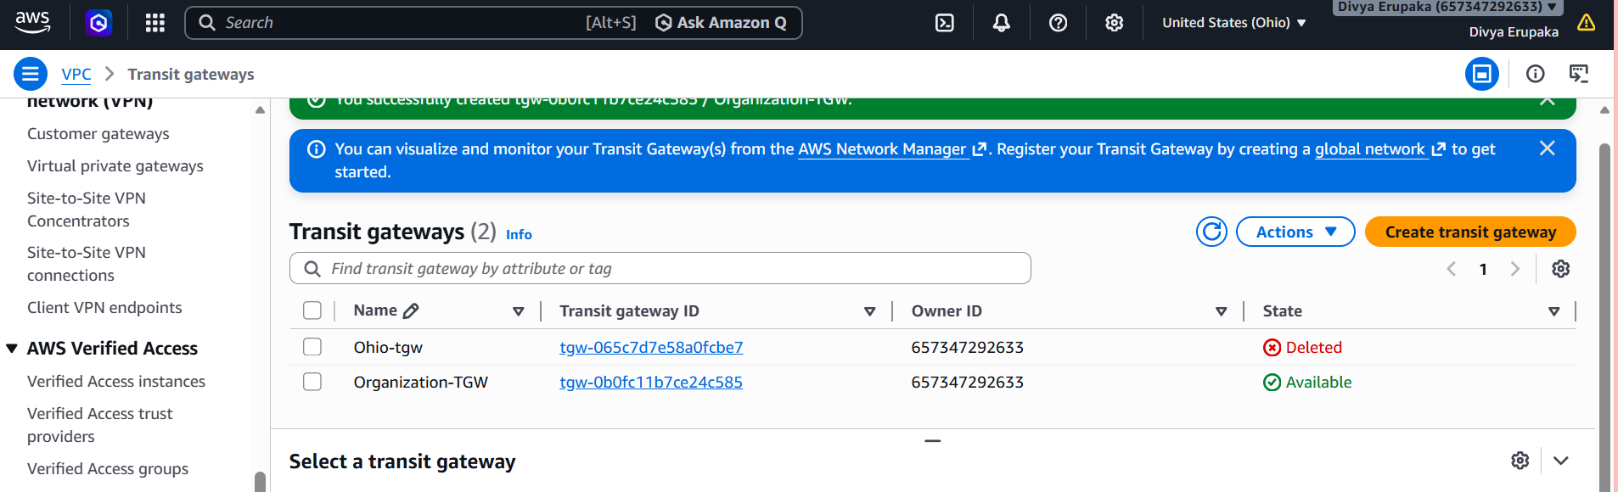
Step 10 – Created Transit Gateway Attachments
Attached all VPCs to Transit Gateway.
Attachments Created
- Shared-Services-VPC Attachment
- Application-VPC Attachment
- Database-VPC Attachment
Status:
Available
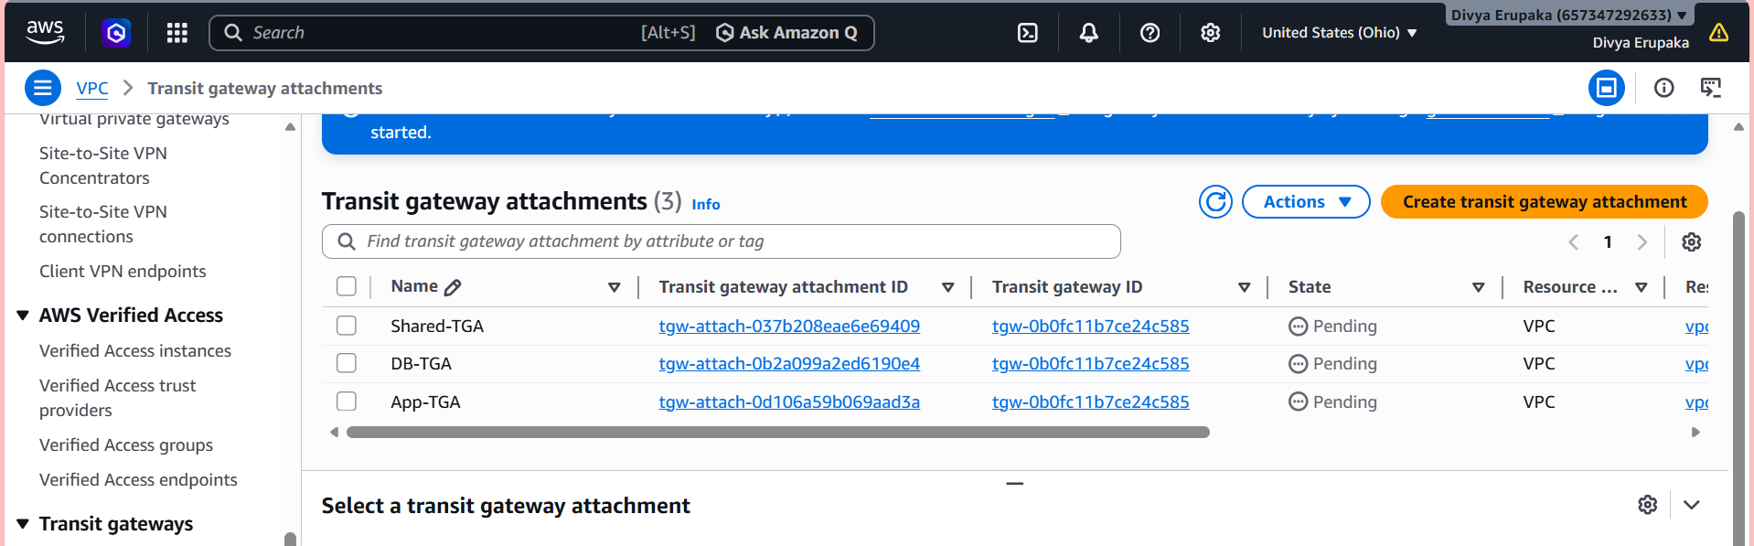
Step 11 – Configured VPC Route Tables
Shared Services Route Table
10.1.0.0/16 → Transit Gateway
10.2.0.0/16 → Transit Gateway
Application Route Table
10.0.0.0/16 → Transit Gateway
10.2.0.0/16 → Transit Gateway
Database Route Table
10.0.0.0/16 → Transit Gateway
10.1.0.0/16 → Transit Gateway

Step 12 – Verified Transit Gateway Route Table
Verified that:
- All VPC attachments were visible.
- Routes were propagated successfully.
- Transit Gateway was forwarding traffic correctly.
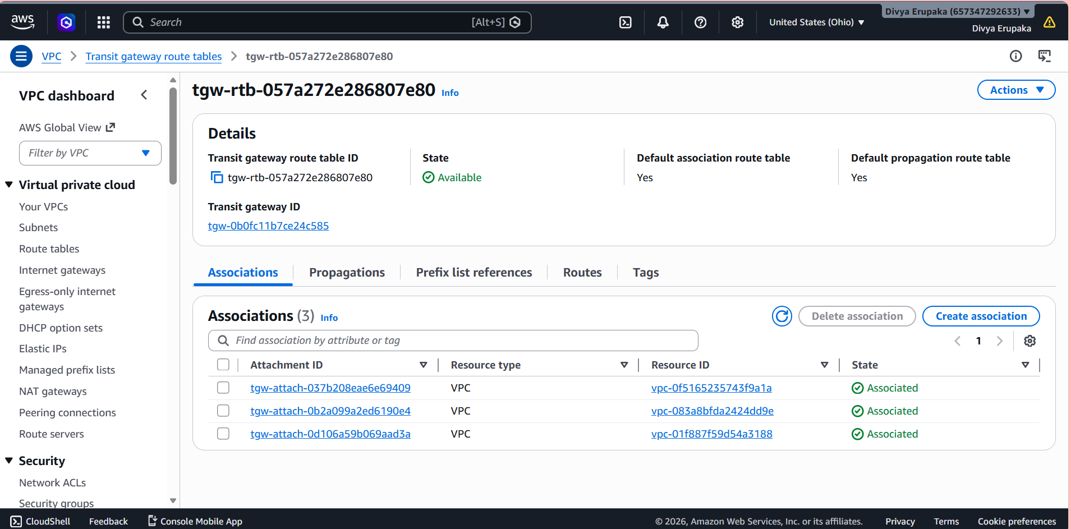
Step 13 – Tested Inter-VPC Connectivity
Connectivity testing was performed using private IP addresses.
Test Commands
ping <Application-EC2-Private-IP>
ping <Database-EC2-Private-IP>
Result
Successful ICMP responses were received.
This confirmed:
- Transit Gateway routing was functioning correctly.
- Inter-VPC communication was successful.
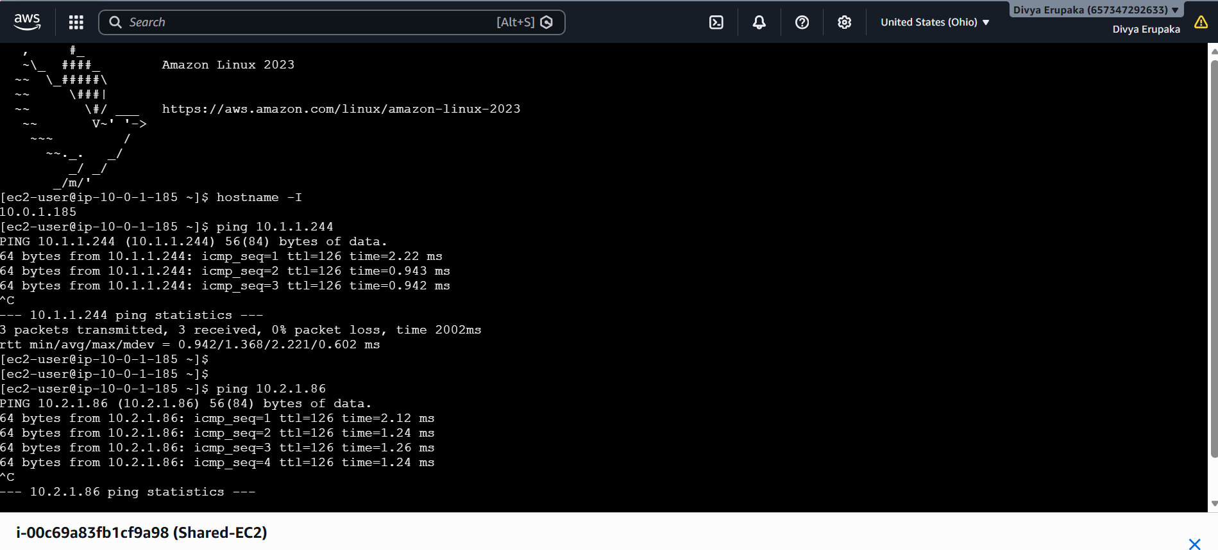
Step 14 – Created S3 Gateway Endpoint
Created Gateway Endpoint:
S3-Gateway-Endpoint
Service:
com.amazonaws.ap-south-1.s3
Type:
Gateway
Purpose:
- Enable private access to Amazon S3.
- Eliminate internet dependency.
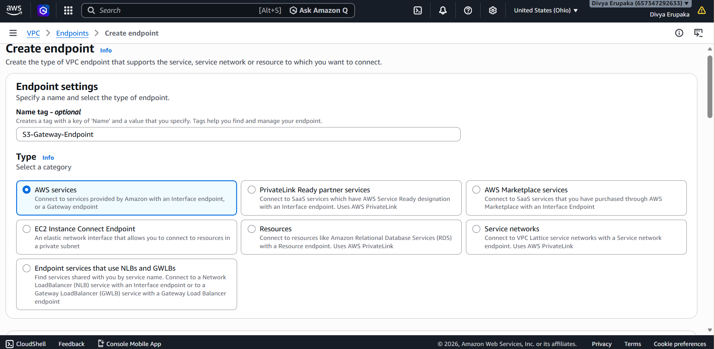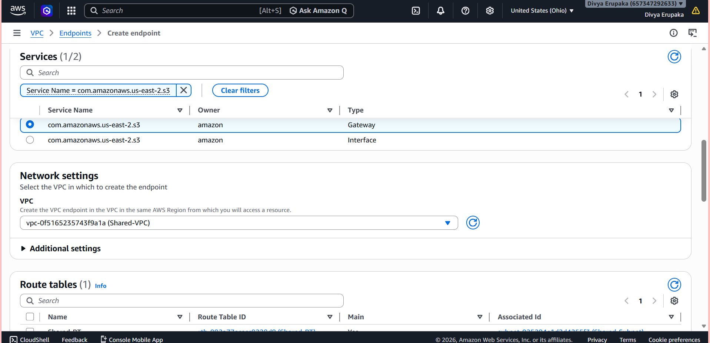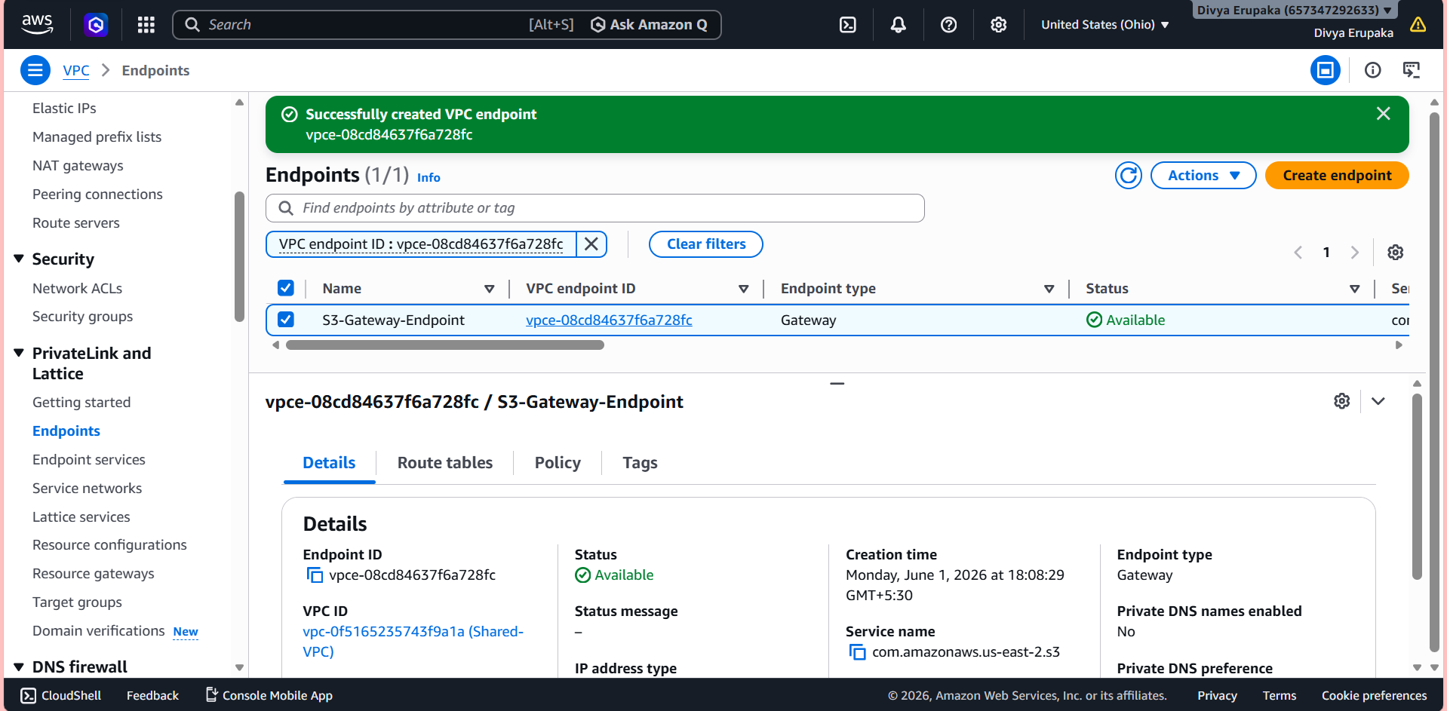
Step 15 – Verified S3 Endpoint
Executed:
aws s3 ls
Result:
Successfully displayed S3 bucket list.
This confirmed:
- S3 traffic was routed through the VPC Endpoint.
- No internet access was required.
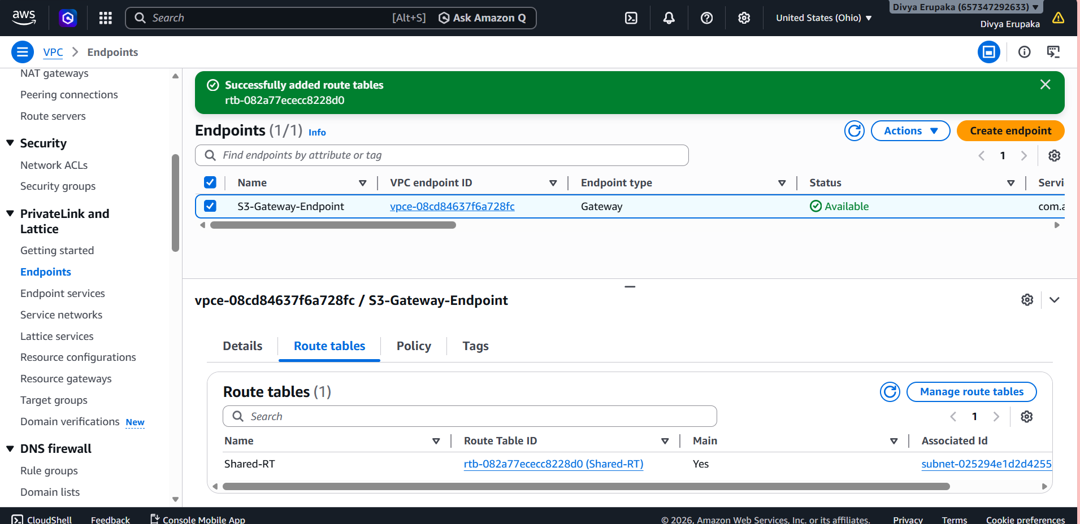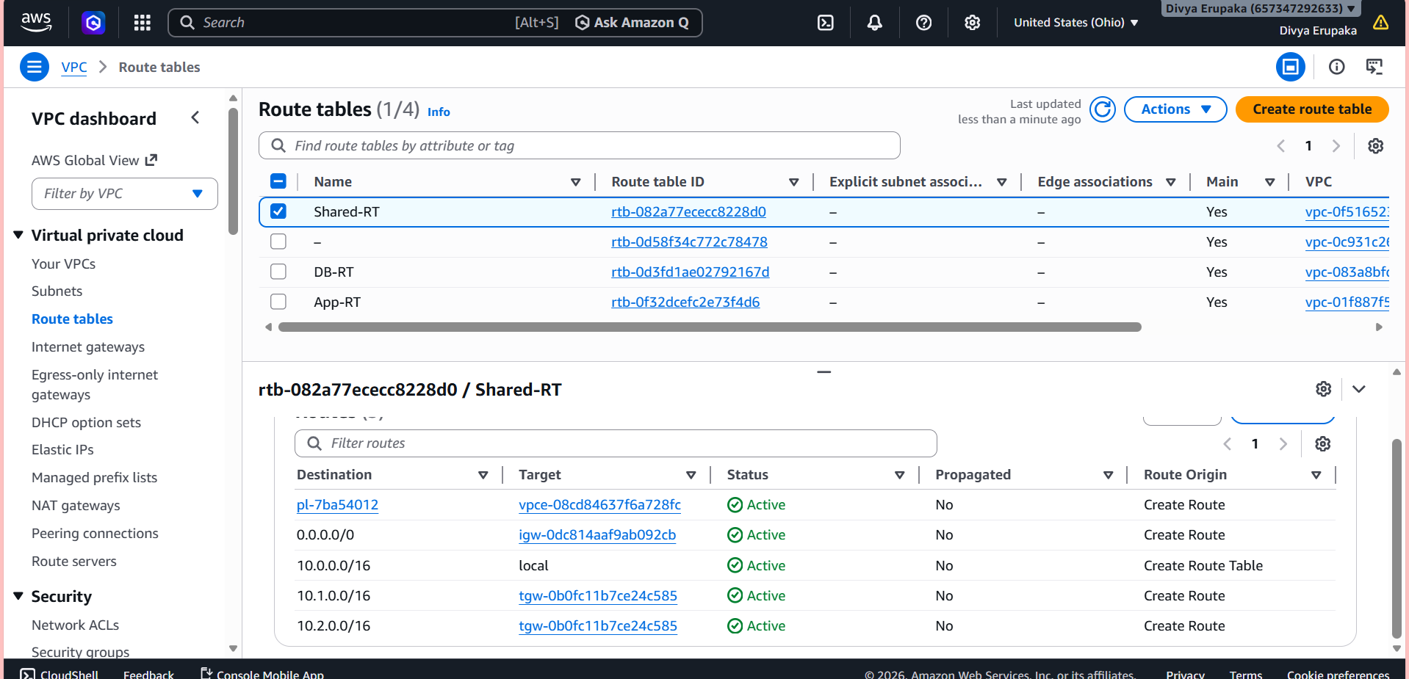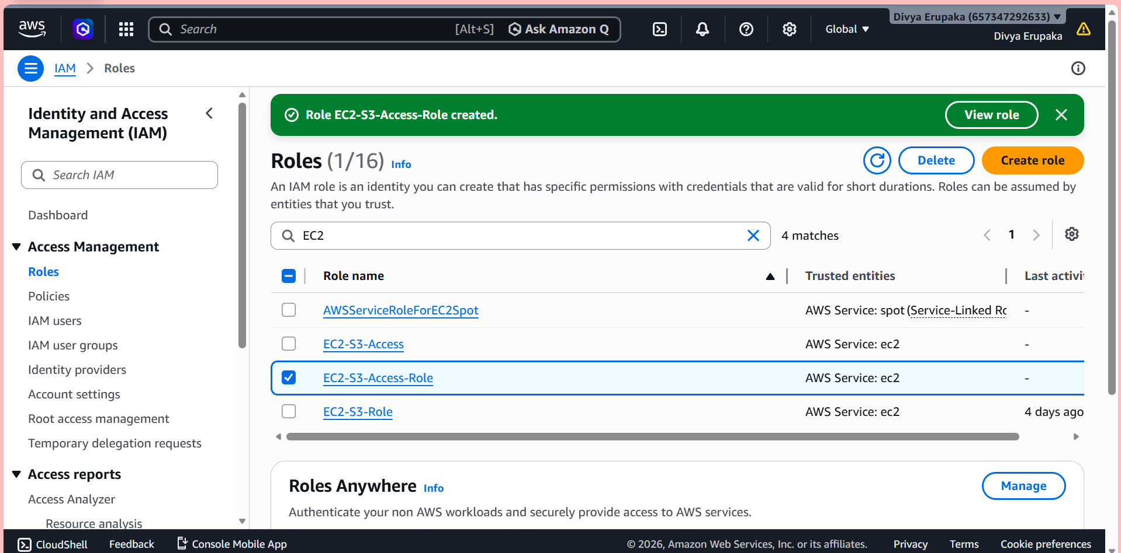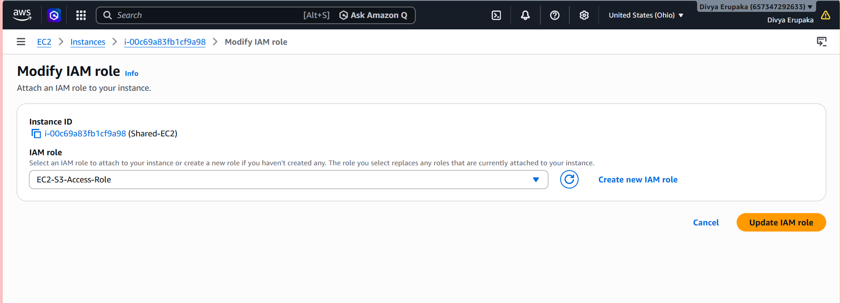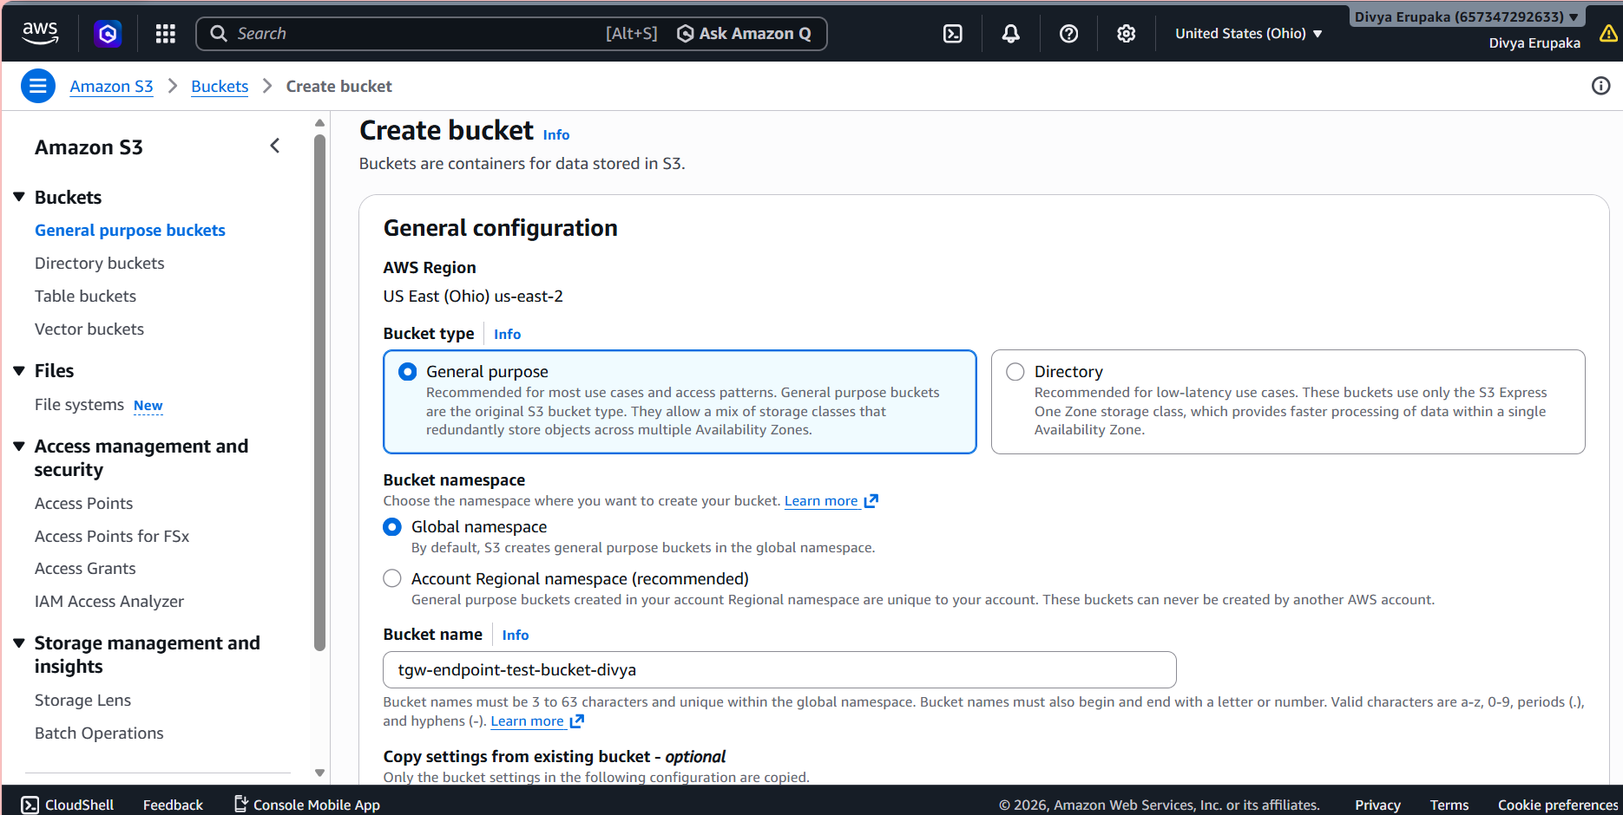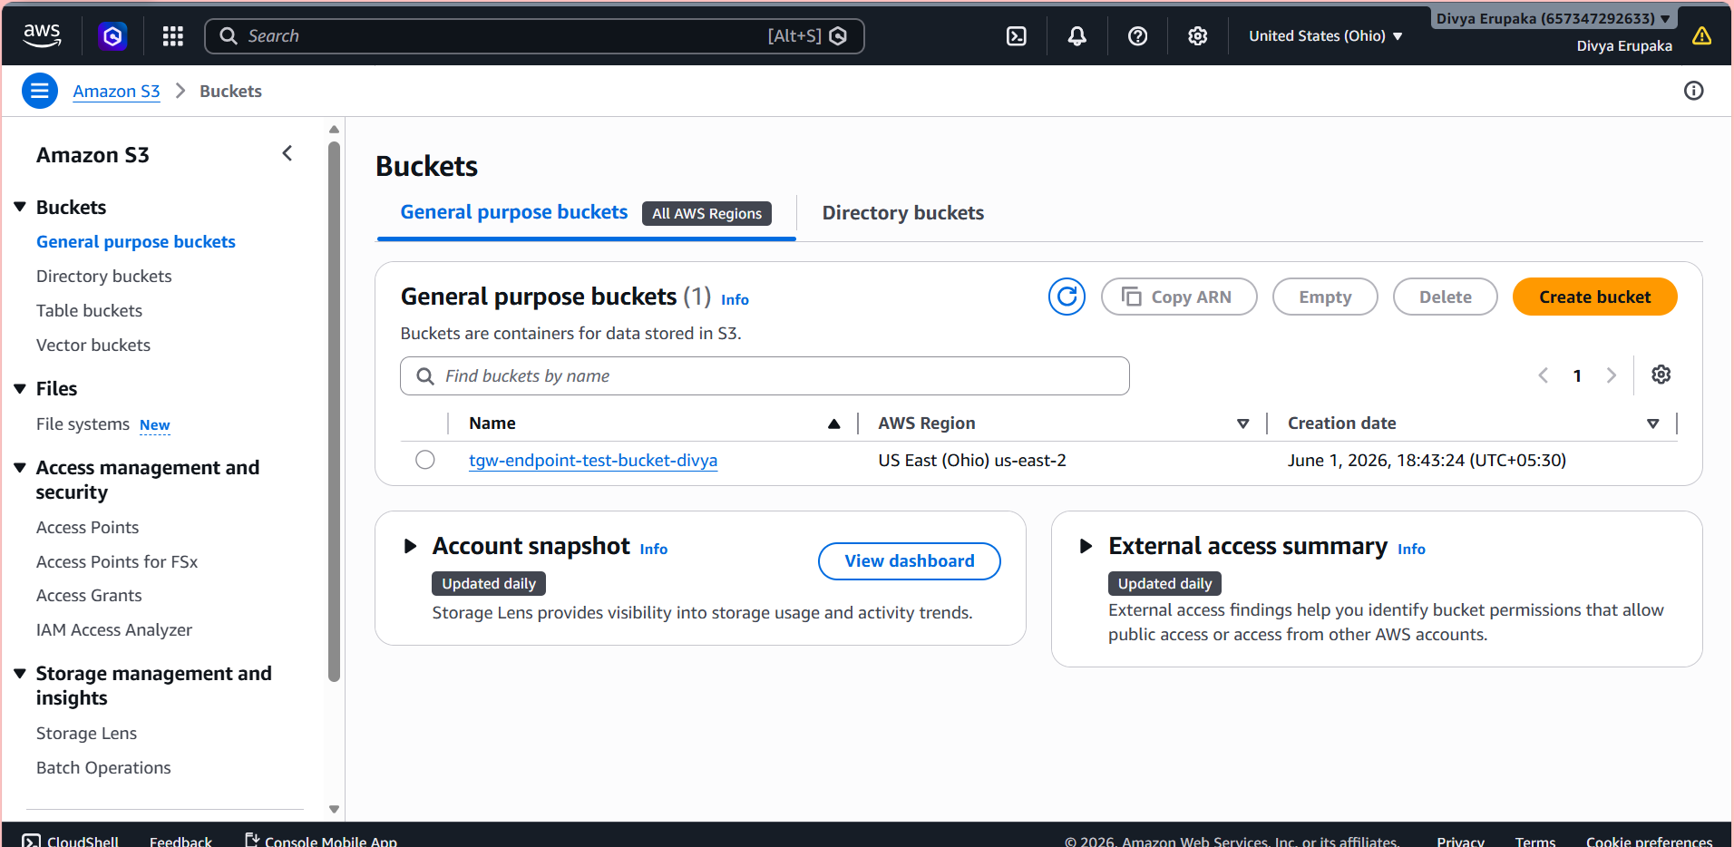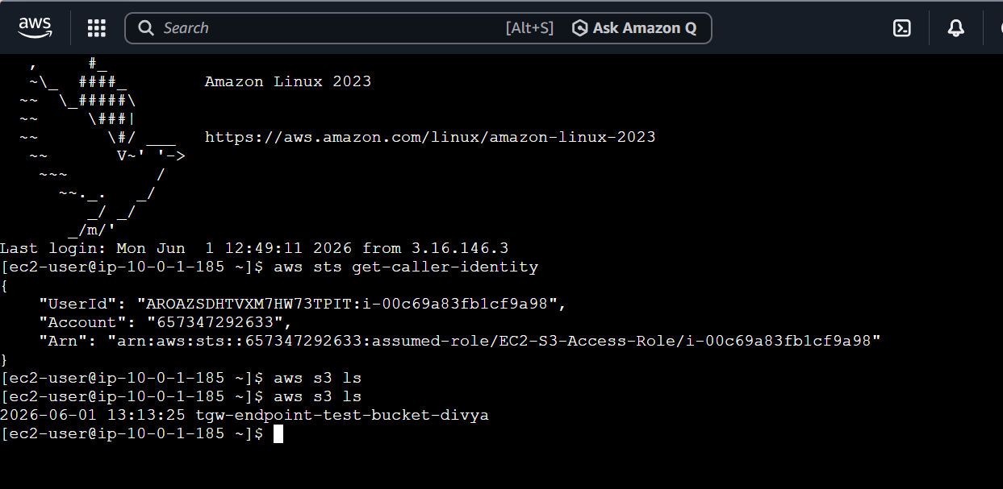
Step 16 – Created Systems Manager Interface Endpoint
Created Interface Endpoint:
SSM-Interface-Endpoint
Service:
com.amazonaws.ap-south-1.ssm
Enabled:
Private DNS
Purpose:
- Secure Systems Manager communication.
- Private connectivity to AWS Systems Manager services.
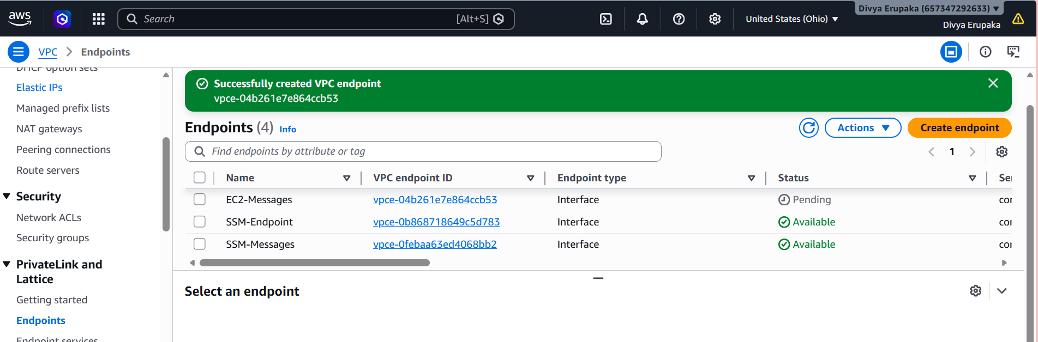
Step 17 – Verified Interface Endpoint
Executed:
nslookup ssm.ap-south-1.amazonaws.com
Result:
Returned private IP addresses.
This confirmed:
- Interface Endpoint was functioning correctly.
- DNS resolution was using private AWS networking.
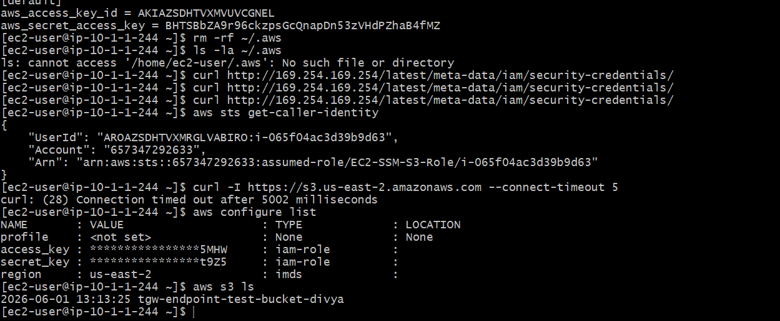
Validation Results
Validation Item | Status
Three VPCs Created | Successful
Three Subnets Created | Successful
Three EC2 Instances Running | Successful
Internet Gateways Attached | Successful
Transit Gateway Created | Successful
Transit Gateway Attachments Created | Successful
Route Tables Updated | Successful
Inter-VPC Connectivity Verified | Successful
S3 Gateway Endpoint Created | Successful
AWS S3 Access Verified | Successful
SSM Interface Endpoint Created | Successful
Private DNS Resolution Verified | Successful

Outcome
Successfully implemented a secure and scalable multi-VPC architecture using AWS Transit Gateway and VPC Endpoints.
The implementation achieved:
- Centralized VPC connectivity through Transit Gateway.
- Simplified network management compared to VPC peering.
- Secure communication between Shared Services, Application, and Database environments.
- Private access to Amazon S3 using Gateway Endpoint.
- Private access to AWS Systems Manager using Interface Endpoint.
- Reduced dependency on Internet Gateway and NAT Gateway for AWS service access.
- Improved security posture and network scalability.

Conclusion
The project successfully demonstrated the implementation of AWS Transit Gateway and VPC Endpoints in a multi-VPC environment. The solution enabled secure communication between isolated VPCs while providing private access to AWS services. This architecture follows AWS networking best practices and can be extended to support additional VPCs and workloads as organizational requirements grow.

